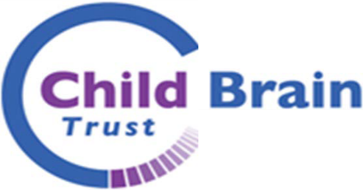
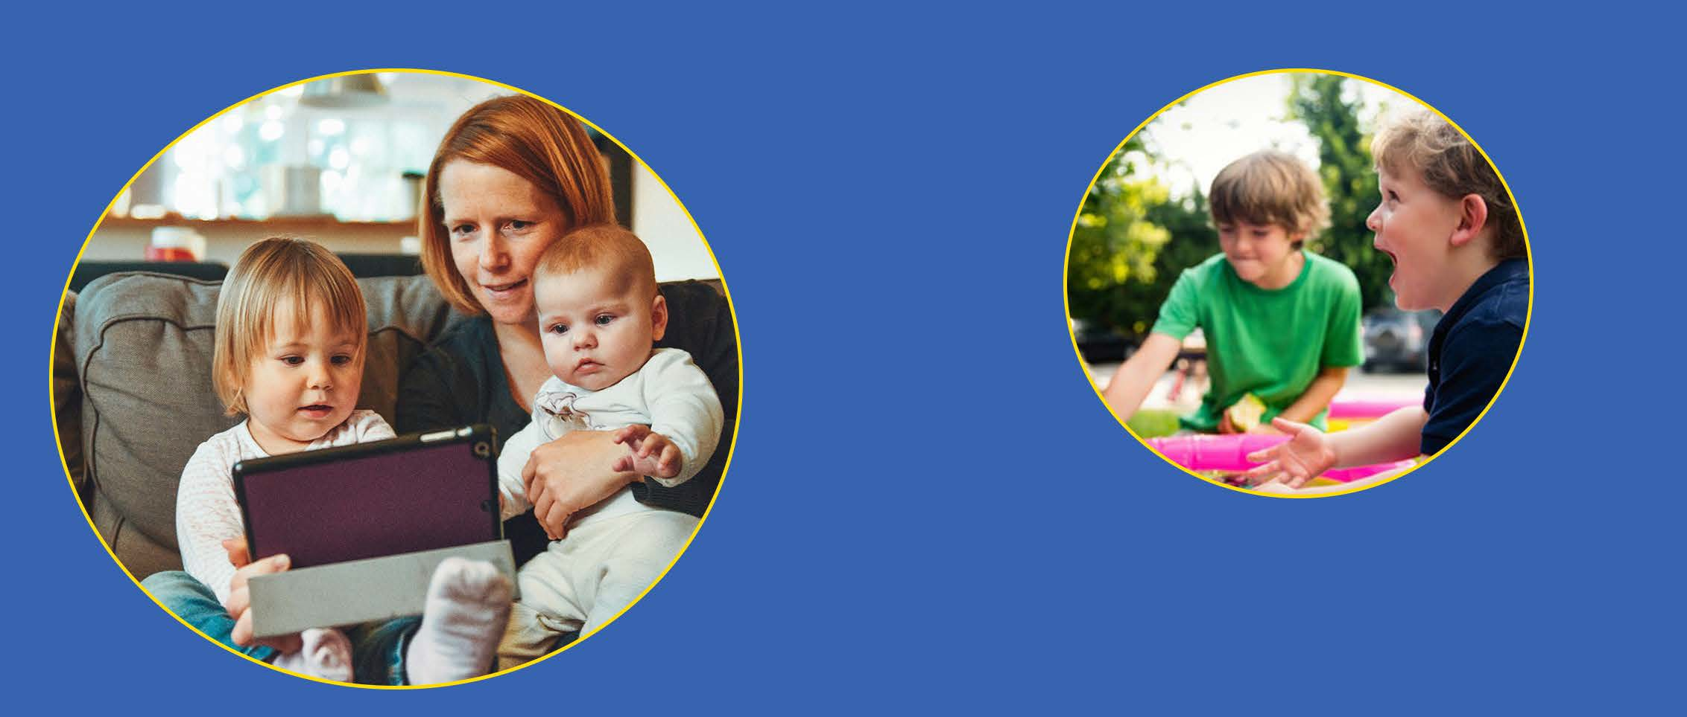
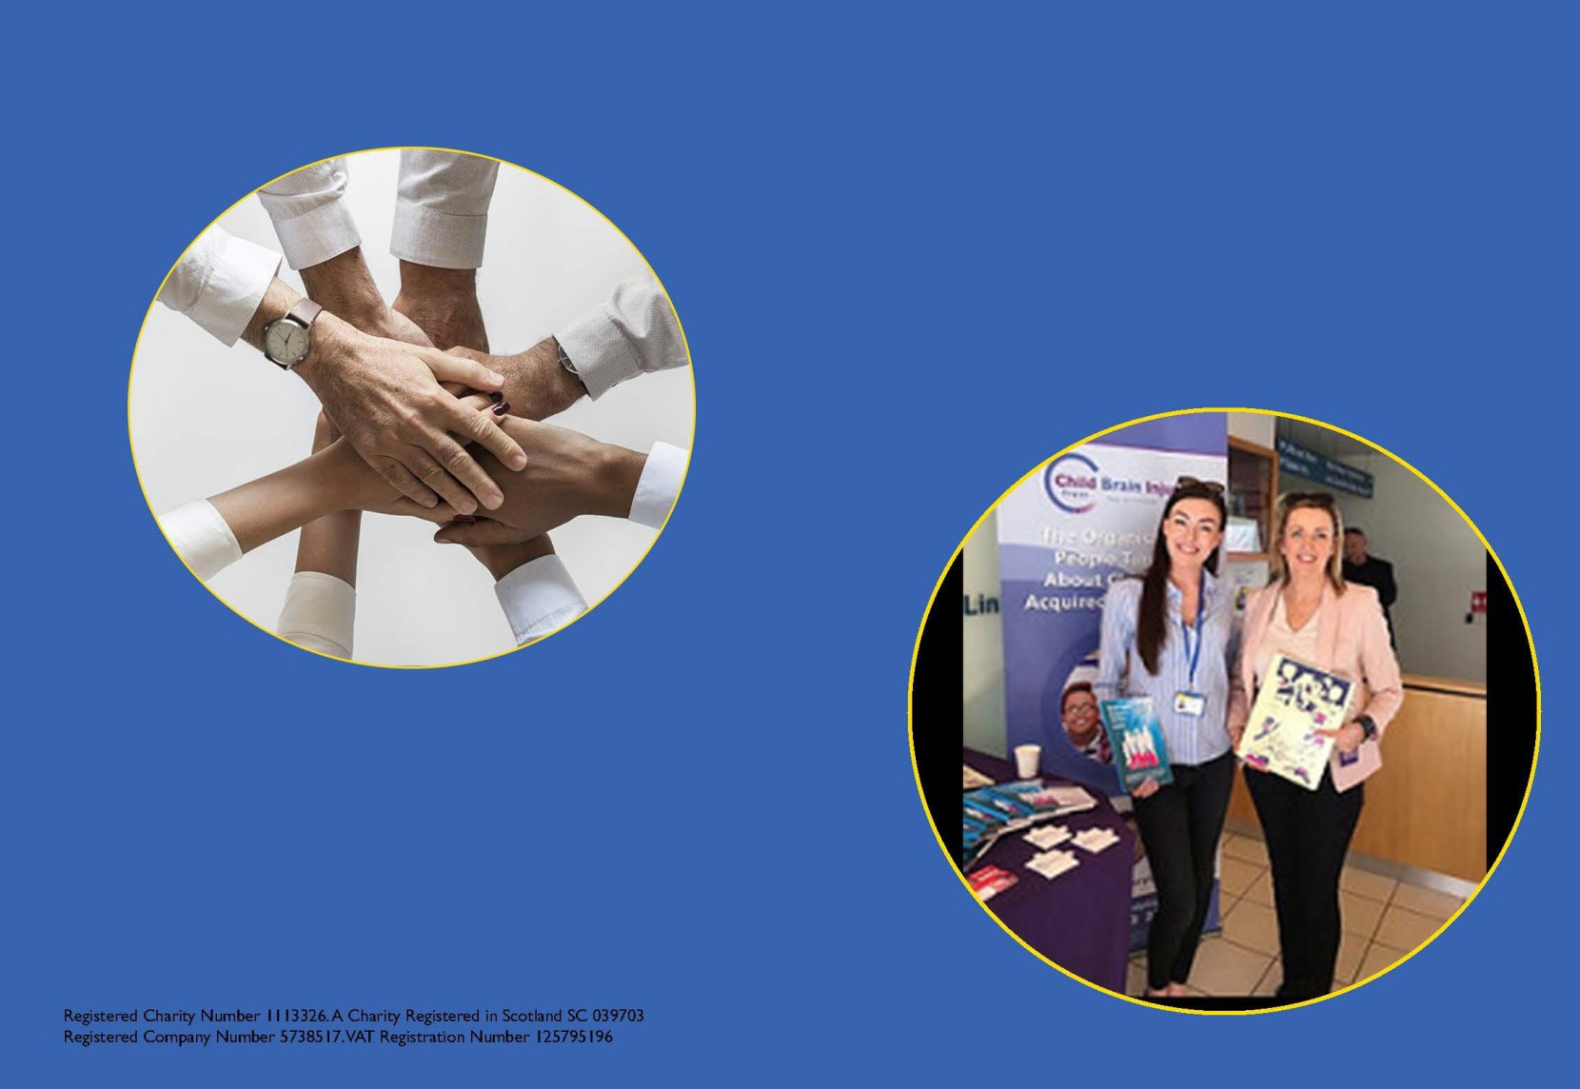
'hope for tomorrow - today'

ABI Coordinator (East Midlands)

Introduction
This recruitment pack has been complied to provide information for prospective applicants applying for the post of:
ABI Coordinator (East Midlands)
It is not intended to be comprehensive, but it is designed to give enough detail to enable applicants to have a good understanding of the job and to assess their suitability.
Should you wish to have an informal discussion about the post please contact:
Name: Gerard Anderson
Job Title: Head of Brain Injury Services
Email: gerardanderson@cbituk.org

Information can also be found on the charity website: www.childbraininjurytrust.org.uk

ABI Coordinator (East Midlands)
Full time 35 hours per week
£22,000 rising to £23,000pa after probation
The Job:
The ABI Coordinator will be home based and also work alongside the Brain Injury Living Life (BRILL) team at Nottingham Children's Hospital working with a multidisciplinary team of professionals. The post holder will provide practical, social and emotional support to families, supporting a smooth transition back home and into community services. The post holder will build a network of professionals and routes to support, working in partnership with the hospital teams and partner brain injury charities to ensure all children and young people affected by childhood acquired brain injury, and their family, are able to access the support they need at the time they need it.
This is a varied and exciting post for the right individual, where no two days are the same! Those applying will need excellent communication skills and will be able to manage their own time and workload with minimal supervision. An understanding of how to build effective support networks locally, working across statutory, voluntary and community sectors to build effective support pathways for CYP is also important. If you are adaptable, solution focused, innovative, have excellent organisational skills and the ability to work with minimal supervision then we are keen to hear from you. You will need to be empathetic, able to engage CYP and, above all, always treat people with respect and dignity.
The successful candidate will have:
- Relevant experience supporting families with additional support needs
- Relevant experience working as part of a multi-disciplinary team
- Excellent communication and interpersonal skills
- An understanding of the educational support needs of CYP with SEN
- An ability to manage work time with minimal supervision
- Excellent IT skills

The Benefits:
The charity is an equal opportunities employer and has flexible working practices:
- A generous annual leave entitlement (25 days per year plus bank holidays)
- Closed between Christmas and New Year
- Workplace pension scheme
- Staff discounts
- Employee Assistance Programme (Health and wellbeing advice & much more)

Closing date: Monday 1st March 2021 (5pm)
Interview date: Tuesday 9th March 2021
To apply for the post, please send a completed application form to office@cbituk.org.
Application forms can be requested from office@cbituk.org or downloaded from https://childbraininjurytrust.org.uk/about/vacancies/

Job Description

Based at: Home working & hospital working
Reporting to: Lead Coordinator
Responsible to: Head of Brain Injury Services
Role overview: To work with families and professionals at Nottingham Children’s Hospital, ensuring that CYP and their families have the appropriate information and support available to them on discharge. To work with community based professionals and partner organisations in ensuring a smooth transition from hospital into community services and back into education, working across the East Midlands.

Tasks and Responsibilities
- Provide practical, social and emotional support to CYP affected by acquired brain injury, focusing on early intervention and working in partnership with clinical and medical professionals at Nottingham Children's Hospital and in partnership with the BRILL Team.
- Establish appropriate networks of professionals and other agencies to effectively support CYP and their family, by expanding the level of support and information available at different transition stages. Establish contact and appropriate partnerships with statutory and voluntary organisations, education and community social work agencies.
- Establish effective referral systems from the acute stage of injury or illness to engage with families and professionals from the onset of ABI.
- Attend key multi-disciplinary team meetings and brain injury clinics (if appropriate) at Nottingham Children’s Hospital, to support a smooth pathway from hospital to home for CYP and their family and back into education and community services.
- Carry out initial assessment of needs reviews with families to assess and evaluate the non-medical and non-clinical needs of the child and family, liaising with hospital, school and community teams where appropriate and act, when necessary, as an advocate for the child and family.
- Work as a member of the multi-disciplinary team at Nottingham Children’s Hospital, attending individual patient-specific discharge planning meetings.
- Work with community and education professionals to provide training sessions on ABI and embed support strategies within schools to help CYP with ABI reach their full potential.
- Where needed, provide training and awareness sessions on ABI to professionals in health, social care and education to help them improve their own practice and improve support for CYP with ABI.
- Create appropriate opportunities for CYP and their families to attend social events, making suitable arrangements with families and acting as host for such events. This may be in conjunction with colleagues at Nottingham Children’s Hospital.
- Set up a network of family support hubs for families and children in the East Midlands to engage in peer support as well as identifying and supporting addressed long-term needs following ABI.
- Maintain individual information and documentation for each CYP and their family, ensuring all calls and enquiries are linked to appropriate family/professionals and that data is updated regularly and in line with General Data Protection Regulation (GDPR) and following Child Brain Injury Trust & Hospital protocol and procedures.
- Produce, in liaison with the CYP, family and colleagues, reports, statistics and evaluation of the service provided as per Child Brain Injury Trust and funder requirements.
- Provide updated information for inclusion on the regional website page and update Facebook to include items of regional significance.
- Ensure the Child Brain Injury Trust team are kept informed of developments in policy, practice and legislation that affects CYP with an ABI in your region.
- Identify opportunities to contribute to improvements in local service provision strategies for CYP affected by childhood ABI and their families.
- Write in-depth family stories to demonstrate the impact of support on CYP and families.
- Work in partnership with the wider charity to identify appropriate development opportunities.
- Maintain a detailed and up to date online calendar, participating in supervisions and team meetings. This may include with Nottingham Children’s Hospital.
- Participate in training and professional development as agreed with line manager and hospital team to develop own expertise.
- Ensure all Child Brain Injury Trust financial, administration, human resource and new technology systems are adhered to and implemented in all aspects of work, all health and safety, and equal opportunities policies are adhered to and all personal responsibilities about these policies are fulfilled suitably.
- Work with regional legal support partners to ensure families have access to timely and appropriate legal support following ABI.
- Attend regular legal support review meeting to discuss cases signposted, ensuring families receive the most appropriate legal support.
- Ensure that all relevant safeguarding procedures, equal opportunities policy and commitment to children’s rights are adhered to when carrying out the duties of the post and that knowledge and skills are kept up to date. Including training as required by Nottingham Children’s Hospital.
- Where required and appropriate, attend occupational health assessments as part of hospital Trust honorary contract procedures.
- Carry out additional duties as and when instructed by your line manager, head of brain injury services or the chief executive.

Budget responsibility

The post holder will not be a budget holder. Responsibility will include the monitoring of expenditure and income and financial reporting for work undertaken.

Revised January 2020

Person Specification

 |  | Evidence obtained from:
 | Essential/ Desirable | Application Form | Interview | Presentation
Knowledge & Experience
An appreciation of the issues and challenges associated with childhood acquired brain injury and the impact that this has upon the whole family | Essential
Experience of working with children and family focussed services | Essential
Experience of managing a varied workload and delivering to tight deadlines | Essential
Experience of successfully building an effective network of support for families | Essential
Experience of working with clinical professionals and building effective support pathways | Desirable
Knowledge of the support services available to children and families in the region | Desirable
Experience of assessing needs and developing appropriate plans to facilitate effective support | Desirable
Degree or equivalent in a related subject | Desirable
Experience of reporting to stakeholders and monitoring outcomes. | Essential
Experience of working within the charitable and voluntary sector | Desirable
Experience of delivering training/presentations to a variety of audiences | Essential
Knowledge of the educational support needs of children with additional support needs | Essential
Understanding of the financial and practical support needs of families in crisis | Desirable
Skills
Able to work remotely and manage own workload with minimum supervision | Essential
Excellent networking skills, able to establish effective networks with professionals at all levels | Essential
Excellent verbal and written communications skills, with the ability to communicate with a wide range of audiences including children and their families and health, education and social service professionals | Essential
Ability to effectively manage relationships under emotional and stressful circumstances | Essential
Ability to work as part of a remote multi skilled team and to manage own workload to deliver required outcomes | Essential
Creative approach to problem solving and finding solutions to complex challenges for families. | Essential
Good administration and IT skills | Essential

Attributes
Committed to ensuring CBIT is the organisation to which people turn regarding childhood acquired brain injury | Essential
Commitment to raising awareness of the impact of childhood acquired brain injury and acting as a champion for the cause | Essential
Commitment to representing the rights of the child and their families in line with UNCRC | Essential
Flexible person-centred approach to delivering services that meet the needs of children and their families | Essential
Practical Circumstances
Full clean driving license and access to a car insured for work purposes | Desirable
Ability to work flexibly within the region, including some evening and weekend work as appropriate | Essential
Dear Applicant,

RE: ABI Coordinator – (East Midlands)
Thank you for expressing an interest in the above-mentioned post at the Child Brain Injury Trust.
Please find enclosed the Job Description and Person Specification. To find out more about the work of the Child Brain Injury Trust, applicants are asked to visit our website at www.childbraininjurytrust.org.uk
Please note that we send all our correspondence by email to save on postage costs.
The deadline for receipt of applications is Monday 1st March 2021 (5pm), with interviews taking place Tuesday 9th March 2021. It is anticipated that candidates shortlisted for interview will be notified by Tuesday 2nd March 2021by email. Unfortunately, we cannot contact those who have not been shortlisted so if you have not heard from us by this date, please assume you have not been successful on this occasion.

What makes a good application?
You need to stand out from the crowd. What we are looking for is for you to tell us how you meet the criteria and why you would make the perfect candidate. Read through the person specification carefully, and address the criteria carefully.
This is your opportunity to market your skills and experience to those shortlisting for the role. Do not assume that we can work out what you have done from a job title, be clear about why you feel you meet the criteria and what you have done so far in your career that demonstrates this.
If you have any queries regarding the post, please contact Gerard Anderson (Head of Brain Injury Services) by email initially at gerardanderson@cbituk.org to arrange a time to chat.

Thank you for your interest in this post, and we look forward to receiving your application.

Child Brain Injury Trust

BACKGROUND INFORMATION ABOUT THE CHILD BRAIN INJURY TRUST
An acquired brain injury is an injury to the brain that has happened after birth. It is not something that families can plan for or are likely to expect, but the truth is that it may change lives forever. Some CYP do have significant physical difficulties after an ABI, however it is often referred to as a hidden disability because of how it affects the way a person thinks, feels and responds to situations.
Every thirty minutes in the UK a child acquires a brain injury, yet little is known about this high incidence disability. As a result, families often find themselves struggling to have their child’s needs met. Leaving hospital and returning to education is often a good sign that things are better, and to some extents and purposes, this is true. The reality however is that children by their very nature are in a constant state of development and change, meaning that needs are likely to change and emerge over time as the young person develops. Added to this is the fact that teenage years are when most young people begin to fine tune skills such as independence and the ability to plan their life. As a result, difficulties in these areas can become much more obvious, particularly as adult support lessens.
The amount of information a parent or carer receives about their child’s brain injury will depend on where they live, which hospital their child was admitted to, how much professionals knew, and what parents have discovered for themselves. Information should not be dependent on all these things – it should be provided to parents regardless.
The Child Brain Injury Trust was originally set up by a group of medical professionals. The organisation has evolved over the years and become the leading UK organisation supporting families and professionals affected by childhood acquired brain injury. Working in consultation and collaboration with families and professionals, the charity aims to ensure families are able to access the support they need, when they need it.
The Child Brain Injury Trust has two regional offices in the UK, namely Oxfordshire (Head Office) and Belfast, and currently employs 36 members of staff. Work is funded from a number of sources, including Trusts, Service Level Agreements with statutory services, and supporter fundraising.
More information about the Child Brain Injury Trust can be found at www.childbraininjurytrust.org.uk

INFORMATION AND GUIDANCE NOTES FOR APPLICANTS
Please read these notes to assist you in your application

Job Description
This gives you a basic summary and details of what the role entails. Read this carefully as this will assist you to complete the application form.

Person Specification
This is a list of the skills and attributes that the Child Brain Injury Trust is looking for in a person. It is essential that you demonstrate these skills in your application form and covering letter. Short listing candidates for interview will be based on how well candidates demonstrate that they meet the Person Specification. Any candidates that do not demonstrate how they meet these criteria are unlikely to be shortlisted.
Invitation for Interview | All applicants will be notified in writing via email as to whether they have been shortlisted for interview
Hours of Work | The role is full time – 35 hours per week. Due to the nature of our work, staff are sometimes required to be flexible in terms of when these hours are worked, and there will be occasions when staff may work additional hours or weekends in fulfilment of their roles.
Induction | All staff will undergo a period of induction once employment commences of a minimum of 4 weeks.
Probation | All new employees are required to complete a satisfactory 6-month probationary period. During this time, progress against objectives defined by the person specification and milestones will be measure and staff will be expected to demonstrate their performance and competency within these areas.
Annual Leave | Annual leave is currently provided at 25 days a year (pro rata for part-time posts). Leave runs April to March. In addition to this, staff are entitled to full pay for all public and bank holidays and given additional time off between Christmas and New Year as the office is closed.
Sickness/Absenteeism | During a new employee’s probationary period, sickness and absence, other than any authorised leave, will be paid as SSP (statutory sick pay), and not provided until the fourth consecutive day of absence.
Pension | New staff are enrolled on Auto Enrolment pension scheme and full details will be provided upon appointment.
Mileage Allowance | Employees are reimbursed when required to use their own vehicles for official business. Employees are required to be insured for business use if using their own car. If appointed, you will be required to produce your driving licence and evidence of appropriate insurance. All information will be provided within the travel and expenses policy.
Relocation Expenses | The Child Brain Injury Trust regrets that it cannot provide relocation expenses to staff.
Maternity Leave | All female employees are entitled to basic maternity leave of 26 weeks, subject to 26 weeks of continuous service at the expected week of confinement (EWC).
Paternity Leave | The Child Brain Injury Trust pays one week at full pay, followed by one week at SPP (Statutory Paternity Pay), subject to 26 weeks continuous service at the expected week of confinement (EWC).
No Smoking Policy | The Child Brain Injury Trust operates a smoke free policy. The policy only relates to an employee’s own vehicle if it is being used to transport colleagues and/or service users.

How to apply
Please email your completed application form to office@cbituk.org or, if not possible, via post to:
HR Department
Child Brain Injury Trust
Unit 1, Baynards Green Farm
Near Bicester
Oxfordshire
OX27 7SG
Please mark your application “Private & Confidential” and ensure that your postal application arrive by the closing date of Monday 1st March 2021 (5pm).

