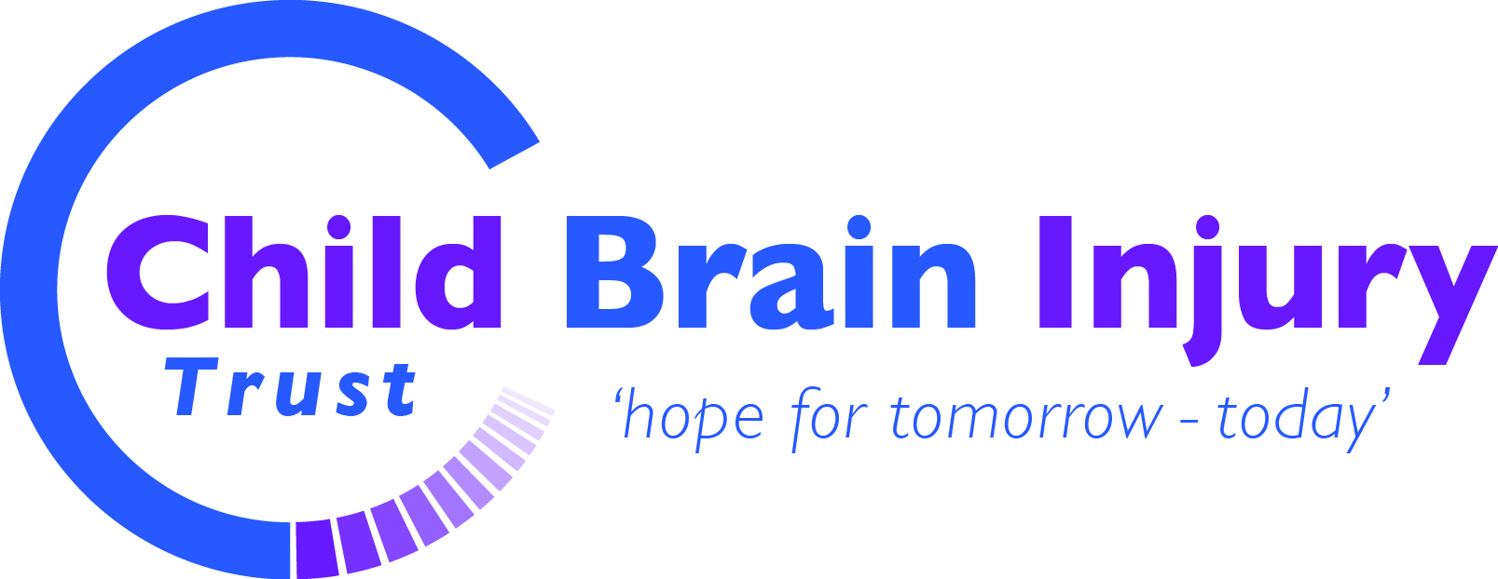
Child Brain Injury Trust Child and Family Support
Referral form for professionals
Guidance for professionals
The Child Brain Injury Trust is a national charity supporting children, families and professionals affected by CHILDHOOD ACQUIRED BRAIN INJURY. For the purposes of our work, the Child Brain Injury Trust defines acquired brain injury as an injury to the brain that has happens AFTER birth. The Child Brain Injury Trust is a plain speaking organisation providing localised support, training and information to children, families and professionals affected by childhood acquired brain injury across the UK.
Child Brain Injury Trust staff have a wealth of expertise on childhood acquired brain injury and can support families through the transition into adult services, up to their 25th birthday. The Child Brain Injury Trust enjoys being able to work in partnership with professionals in order to achieve the very best outcomes and opportunities for children and families.

IDEALLY, THIS FORM SHOULD BE TYPED; OTHERWISE PLEASE WRITE CLEARLY IN BLACK PEN. Thank You.
REFERRER’S DETAILS:
Full name: _______________________________________________________________________
Job title: _________________________________________________________________________
Name of organisation: ______________________________________________________________
Department: ______________________________________________________________________
Address: _________________________________________________________________________
_________________________________________________________________________________
_________________________________________________________________________________
_________________________________________________________________________________
Telephone: _____________________________ Email: ____________________________________
Has the family consented to involvement with the Child Brain Injury Trust? YES/ NO
If yes, please complete the details on the following pages. The family’s personal information will be treated in the strictest confidence but may be shown to the family if requested.
If no, the Child Brain Injury Trust can provide you with additional information to pass onto the family. Please complete page 2 ONLY, and we will contact you to discuss the sort of information which may be useful for you to pass on.

Other agencies / organisations involved (please detail)
Contact name | Agency/ Organisation | Telephone
FAMILY DETAILS
Full name of child with ABI:
Child’s date of birth: __________________________________Gender: _______________________________
Date brain injury occur?
How did the brain injury occur?

Main point of contact within family:
Guardian 1 name: ___________________________ Title_______ Role: _____________ Main carer YES/NO
Guardian 2 name: _____________________________ Title______ Role: ____________ Main carer YES/NO
Address:
Postcode:
Telephone:
Mobile :
Email Address:

Name of sibling/s (if known) | Gender | Date of birth

Please identify the main issues for the family:
- Financial
_____________________________________________________________________________________________________________________________________________________________________________________________________________________________________________________________________
- Educational
_____________________________________________________________________________________________________________________________________________________________________________________________________________________________________________________________________
- Health
_____________________________________________________________________________________________________________________________________________________________________________________________________________________________________________________________________
- Accessing services
_____________________________________________________________________________________________________________________________________________________________________________________________________________________________________________________________________
- Within the community
_____________________________________________________________________________________________________________________________________________________________________________________________________________________________________________________________________
- Other issues
_____________________________________________________________________________________________________________________________________________________________________________________________________________________________________________________________________
- Unsure

Given that Child Brain Injury Trust staff will regularly work alone with a child and family, are there any health and/or safety issues that Child Brain Injury Trust staff may need to be aware of?
______________________________________________________________________________________________________________________________________________________________________________________________________________________________________________________________________________

ADDITIONAL INFORMATION
Please use this space to provide any additional information that may assist
the Child Brain Injury Trust Child and Family Support Coordinators in supporting the family

Would YOU like to receive regular information from the Child Brain Injury Trust, such as notification events for families or workshops for yourself? YES/ NO
Your details will NOT be passed on to any third party

Please return your completed form to the Child Brain Injury Trust at the address below:
Child & Family Support Team
Child Brain Injury Trust
3 Field View,
Baynards Green Trading Estate,
Baynards Green,
Nr. Bicester,
Oxfordshire,
OX27 7SR

Document Control | Document ID | 160
 | Issue Date | May 2017
 | Last Reviewed | January 2019
 | Next Review due by | January 2020
 | Version Number | 1.2

